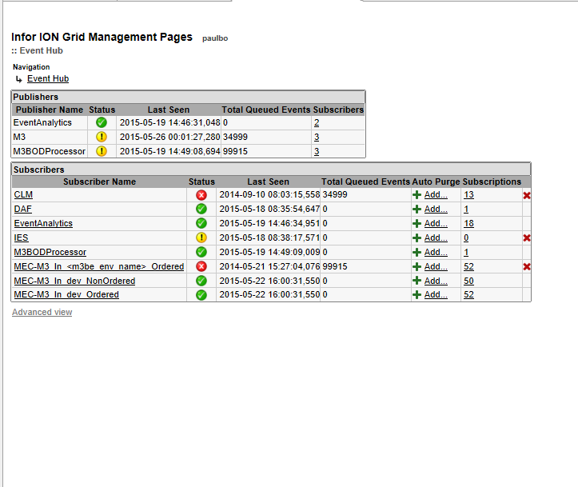

Publisher Event Analytics - Subscribers

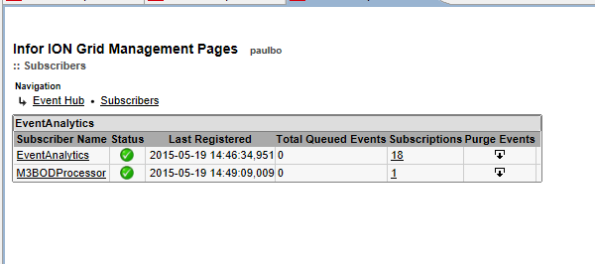

Publisher M3 – Subscribers



Publisher M3BODProcessor

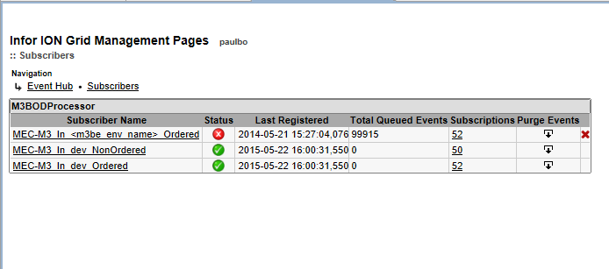

Tracking where the event hub trigger or publishers come from for MEC

MEC Partner Admin – Manage – Communications

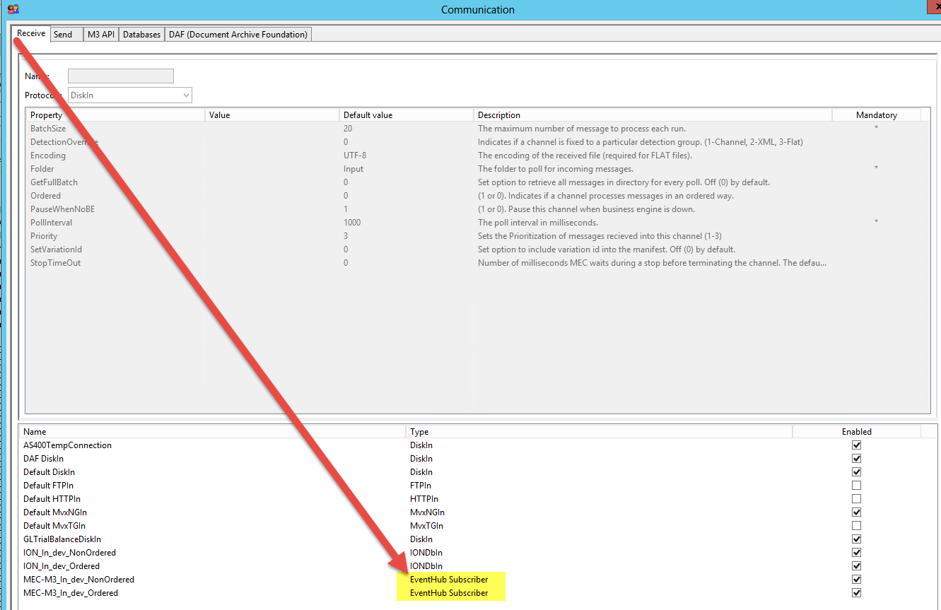

LCM Event Hub

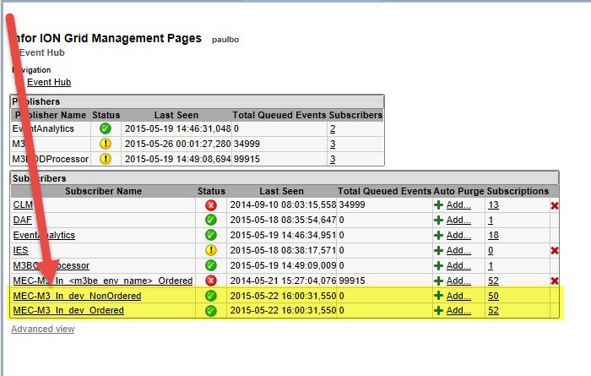

MEC-M3 In dev Ordered

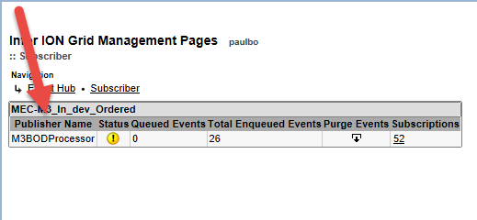

Subscriber – M3BODProcessor

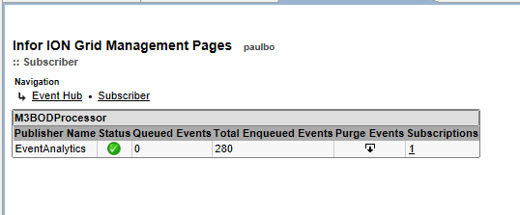

Publisher – EventAnalytics

